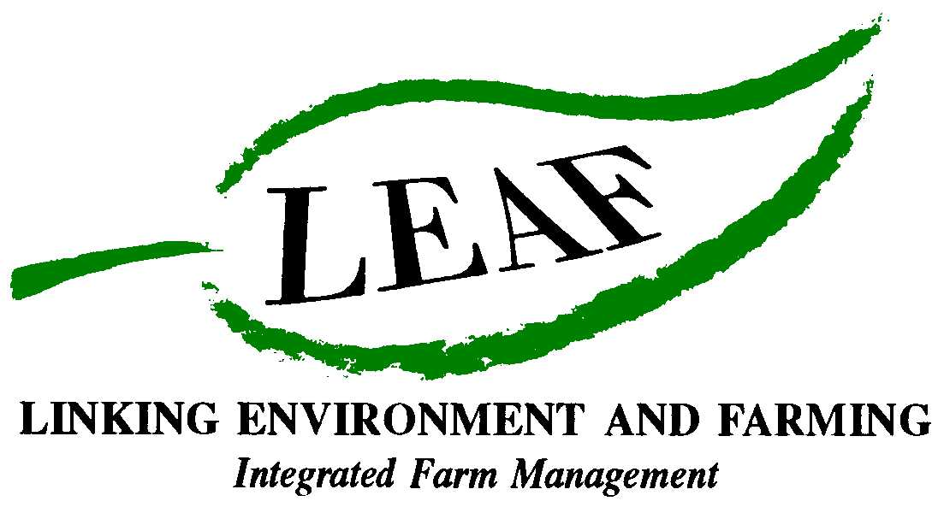
Who are LEAF?

History
- LEAF (Linking Environment And Farming) was set up in 1991, by a group of key farming industry experts. The aim was to encourage other farmers in the UK to produce food with care for the environment and to improve public understanding of food and farming
- The idea was inspired by Germany’s farmers who were changing the way they farmed the land to make it more environmentally friendly
- Nowadays, LEAF promotes environmentally responsible farming. They support farmers to produce good food, with care and to high environmental standards, identified in-store by the LEAF Marque logo. They also build public understanding and trust of food and farming in a number of ways, including Open Farm Sunday and visits to a national network of Demonstration Farms
- For more information visit: www.leafuk.org

LEAF’s main activities
- The LEAF Marque: is a food label you can trust. You will find the LEAF Marque logo on produce, including food and drink, sold nationwide in supermarkets, such as Waitrose, farm shops and farmers’ markets. By buying LEAF Marque produce, you can enjoy food you can trust from farmers who care for the countryside and wildlife on their farms
- Open Farm Sunday: is a national, annual event which sees hundreds of farms open their gates to the general public. It is a great opportunity for visitors to discover how our food is produced and how farmers care for the countryside. Open Farm Sunday 2011 will be held on 12th June. For more information visit www.farmsunday.org
- Integrated Farm Management (IFM): LEAF’s IFM ensures the highest standards of food production with minimum impact to the environment and encourages a better public understanding of farming and countryside matters. What makes LEAF’s IFM different is its ability to balance quality production with the environment and social responsibility across the whole farm and considers each farm’s specific requirements on an individual basis
- Demonstration Farms: Learn more about LEAF and IFM by visiting one of LEAF’s nationwide network of Demonstration Farms. LEAF farmers host visits for a wide range of groups – from farmers to politicians, teachers to WI groups, so you can see for yourself how IFM can produce affordable food in harmony with the environment
- Virtual Farm Walk: like a real farm, the Virtual Farm Walk is a great place for learning for all key stages of the national curriculum. From maths to geography, art to English, science to IT, it gives children the chance to understand what happens in the countryside to produce food and care for wildlife. For more information visit www.virtualfarmwalk.org

Key staff
- Caroline Drummond, Chief Executive of LEAF, was awarded an MBE for Services to Agriculture in 2009 and has been leading LEAF since it was established in 1991
- Jeremy Boxall, Commercial Manager of LEAF, has been working for LEAF for over 10 years. Jeremy manages the LEAF Marque scheme, a respected global environmental standard offering consumers a wide range of products that have been produced in accordance with LEAF’s environmental principles

What others have to say about LEAF
"To me, LEAF Marque means that anything I buy with the logo on it has been carefully produced by a farmer who cares about the same things I do: good, wholesome, affordable food, produced with care. I know I am doing the right thing by choosing LEAF Marque produce. I am supporting a charity that supports farmers to farm as well they possibly can. I can visit LEAF Demonstration farms if I want to, and ask the questions I have a right to ask about the food I buy for my family."
Fiona Catherall, consumer

For further information or to become a friend of LEAF and support the future of environmentally responsible farming visit www.leafuk.org.
- Ends -
For further information and images, to arrange an interview or to obtain industry comment:
David Gough
LEAF Press Office
T: 01189 475 956 / 07884353474
E: david.gough@ceres-pr.co.uk

Editor’s Notes:
- LEAF (Linking Environment And Farming) promotes environmentally responsible farming. We support farmers to produce good food, with care and to high environmental standards, identified in-store by the LEAF Marque logo. We build public understanding and trust of food and farming in a number of ways, including Open Farm Sunday and visits to our national network of Demonstration Farms
- For more information on all LEAF’s work and activities, visit www.leafuk.org

