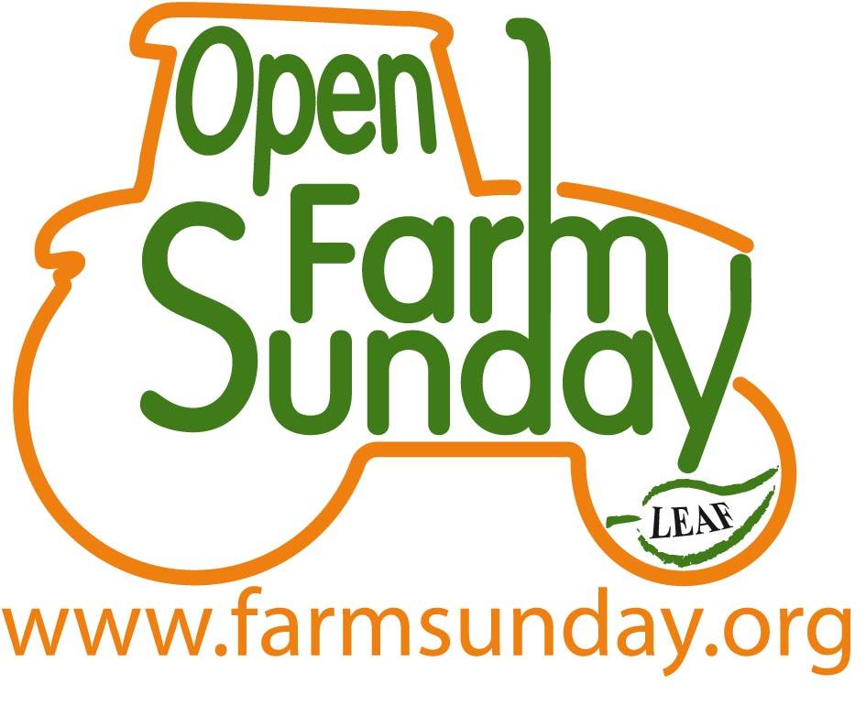
Open Farm Sunday Prayers
Two prayers kindly supplied by
The Rev’d Dr Gordon Gatward, Director, the Arthur Rank Centre

There are more animals than can be counted,
Bigger tractors and combines than can be imagined,
And an assortment of complicated machinery
That’s confusing just to look at let alone operate.

This is farming as we didn’t expect it,
No hens pecking round the farmhouse door,
No pig in a sty, no milk churns, no nostalgia.
For this is new, it’s fresh, it’s exciting;
LORD, OPEN OUR EYES TO THE WONDER THAT IS FARMING.

Help us appreciate
the glory and responsibility:
of producing food whilst managing the countryside;
of achieving standards and meeting deadlines;
of battling with the weather, with pests and with prices;
LORD, OPEN OUR EYES TO THE WONDER THAT IS FARMING.

Help us appreciate
the depth of skill and knowledge
that all this demands;
the investment of time, money and effort
that it requires;
the commitment and dedication
that it involves;
LORD, OPEN OUR EYES TO THE WONDER THAT IS FARMING.

Help us appreciate
those who work the land
and tend the stock;
those who supply the seed, the machinery,
the fertilisers, the feed;
those who provide the advice
and those who buy the produce;
LORD, OPEN OUR EYES TO THE WONDER THAT IS FARMING.

For those who feed us
and for those who support them;
for the food they grow and rear
and for those who get that food to us;
for the countryside they care for
and the landscape they manage;
LORD, OPEN OUR EYES TO THE WONDER THAT IS FARMING.
AMEN Prayer two next page

For this Open Farm Sunday;
bringing together farmer and consumer,
urban and rural, neighbour and stranger;

building relationships and providing knowledge;
offering new experiences of farming and food,
of what is produced and how it is grown;

providing new insights into wildlife and habitat,
the delicate balance between food production
and environmental management.

For all this day offers, the pleasure it provides
and the understanding that results.
FATHER WE THANK AND PRAISE YOU.
AMEN

