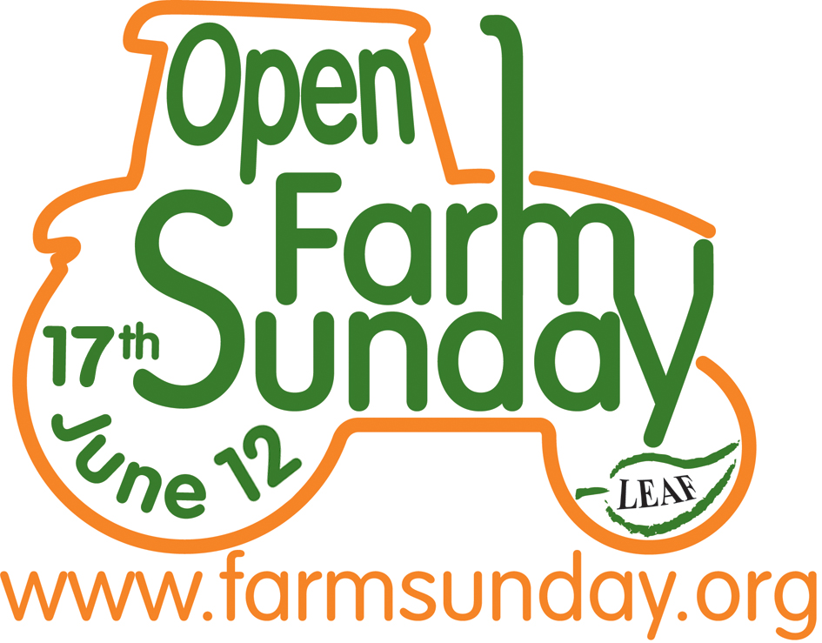
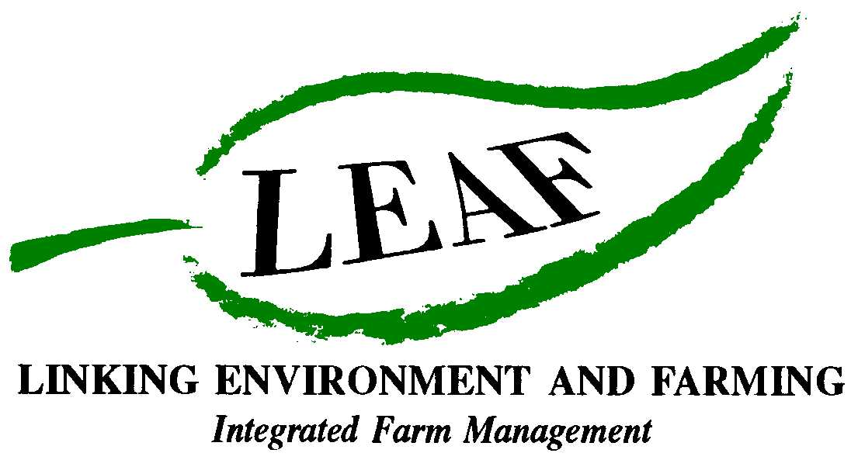

Exciting Plans for Open Farm Sunday 2012
So much for visitors to discover on our farms!

As Open Farm Sunday moves into its seventh year, organisers LEAF (Linking Environment And Farming) are encouraging more farmers than ever to open their gates on the 17th June. Online registration for Open Farm Sunday begins on the 10th January.

Open Farm Sunday has become firmly established as the food and farming industry’s annual flagship event. Reaching out to over one million consumers, it provides an excellent opportunity for consumers to find out about the vital role farmers have in producing safe affordable food whilst caring for the countryside. Following feedback from farmers, sponsors and supporters the 2011 theme – ‘Discover Life On Our Farms’ will remain for 2012, providing exciting opportunities for everyone involved.

Caroline Drummond, LEAF Chief Executive said: “As a nation we are becoming increasingly urbanised and many consumers are still disengaged with the countryside and the story behind their food – which is why Open Farm Sunday is more important than ever. As well as showcasing the industry, Open Farm Sunday is also a fantastic opportunity for farmers to build bridges between themselves and the public and tell them about the valuable work they do and show them at first hand how the food they enjoy every day is produced.”

“The feedback we get from farmers each year shows the wide range of benefits they receive from taking part in Open Farm Sunday and how much they enjoy the day too! Benefits mentioned include building community relations and raising a farm’s profile through to increasing sales. But it is the face to face engagement between farmers and the public that is the most important part of Open Farm Sunday – no matter what the size or type of event.
Be it a guided farm walk at a set time, to a large open day, the choice of event belongs to the farmer. So whether you are opening your gates to 30 or 300 visitors, all events are of equal importance and value. Size doesn’t matter to LEAF – it’s the engagement with the public that really counts.”

There are several new elements planned for Open Farm Sunday 2012 – including a pilot, national Pollinator Survey which is being supported by a long term sponsor and supporter of Open Farm Sunday – Syngenta, in partnership with researchers from the Centre for Ecology and Hydrology and other leading experts. This is a unique opportunity for the public and farmers to work together and for people of all ages to discover at first hand the importance of nature to their food in a fun and engaging way. With the value of insect pollination estimated at £131 billion globally, ‘pollinators’ are clearly very important to farmers and any research that can aid or improve pollination will also be of benefit to the whole industry.

The Pollinator Survey will seek to scientifically record and measure insects visiting flowers on farms across the country on the 17th June with the results then being analysed over the summer months. Full details on how to conduct the survey and order survey forms will be available on the website. LEAF is hoping that many of the farms will sign up to take part in the survey.

LEAF offers farmers a variety of extensive free support to help them run a successful Open Farm Sunday event, whatever its size. This includes:
Website (www.farmsunday.org): A new look website will be launched in early 2012 where farmers can register their event, get lots of helpful information and top tips, view the online Workshop videos, order free resource packs and find out more about Open Farm Sunday, LEAF and the LEAF Marque.
Workshops: These are free to attend and will take place across the UK in February and May 2012. Farmers will be able to meet with other farmers who have hosted open days before and learn from their experiences, as well as get great ideas and advice on a whole range of topics.
Regional Coordinators: There are 10 regional coordinators across the country, many of whom have hosted an Open Farm Sunday event, whose role it is to help farmers with local advice on planning and hosting an event.

A resource pack: This contains publicity material (posters, flyers, etc), suggested activities, Health and Safety guidance and lots more!
For up-to-date campaign information and to let us know about your plans for Open Farm Sunday, follow us on Twitter - twitter.com/openfarmsunday.
- Ends -
For further information and images, or to arrange an interview with a local farmer or preview visit to a participating LEAF farm, contact:

David Gough
Open Farm Sunday Press Office
T: 01189 475956
E: david.gough@ceres-pr.co.uk

Editor’s note:

- LEAF (Linking Environment And Farming) www.leafuk.org is a national charity (Registered no: 1045781) that helps farmers produce food with care for the environment, while working with their local community
- The seventh annual Open Farm Sunday on 17 June 2012 provides a great opportunity for the public to truly get to know how their food is produced and how the countryside around them is cared for
- Visitors will be able to learn from farmers themselves how natural plant and insect species are encouraged to thrive alongside crops, they will get a close-up look at farm animals and see how the needs of wildlife are balanced with modern food production
- LEAF organises Open Farm Sunday and supports farmers with putting on an event that is not only enjoyable, but gives visitors a really fascinating insight into aspects of the countryside that they would not usually see or experience on an average day out
- LEAF supports both LEAF and non-LEAF member farmers by hosting a number of workshops across the country with practical advice and tips for organising successful events. LEAF also provides free promotional support materials and an interactive online event database to register details of farmer events
- An increasing number of farmers are signing up to support LEAF, to demonstrate how they are integrating modern farming with environmental conservation
- Food carrying the LEAF Marque logo shows that it has been grown by farmers who are committed to looking after the countryside and the environment. LEAF farmers are subject to an independent LEAF Audit, designed to help them meet the change in demands placed on operations by legislation, the marketplace, community and the industry
- Sponsors for Open Farm Sunday 2012 include Sponsors for Open Farm Sunday 2012 include Asda, Country Life, John Deere, Farmers Weekly, Frontier Agriculture, LEAF Marque, Marks and Spencer, National Farmers Union, National Grid and Syngenta, plus supporting sponsors BPEX, DairyCo, EBLEX, HGCA, Red Tractor and Farm Stay UK.
- Pollinator Survey: This is being supported by Syngenta in conjunction with CEH
- The Centre for Ecology and Hydrology (CEH) is the UK's Centre of Excellence for integrated research in the land and freshwater ecosystems and their interaction with the atmosphere. CEH is part of the Natural Environment Research Council, employs more than 450 people at four major sites in England, Scotland and Wales, hosts over 150 PhD students, and has an overall budget of about £35m. CEH tackles complex environmental challenges to deliver practicable solutions so that future generations can benefit from a rich and healthy environment. www.ceh.ac.uk You can follow the latest developments in CEH research via twitter www.twitter.com/CEHScienceNews and our rss news feed http://www.ceh.ac.uk/rss/rss.xml
- Keep up to date with LEAF’s activities via twitter www.twitter.com/LEAF_Farming and our regular blogs at leafmarque.wordpress.com.

Diary Note Trade – Open Farm Sunday 2012.doc

