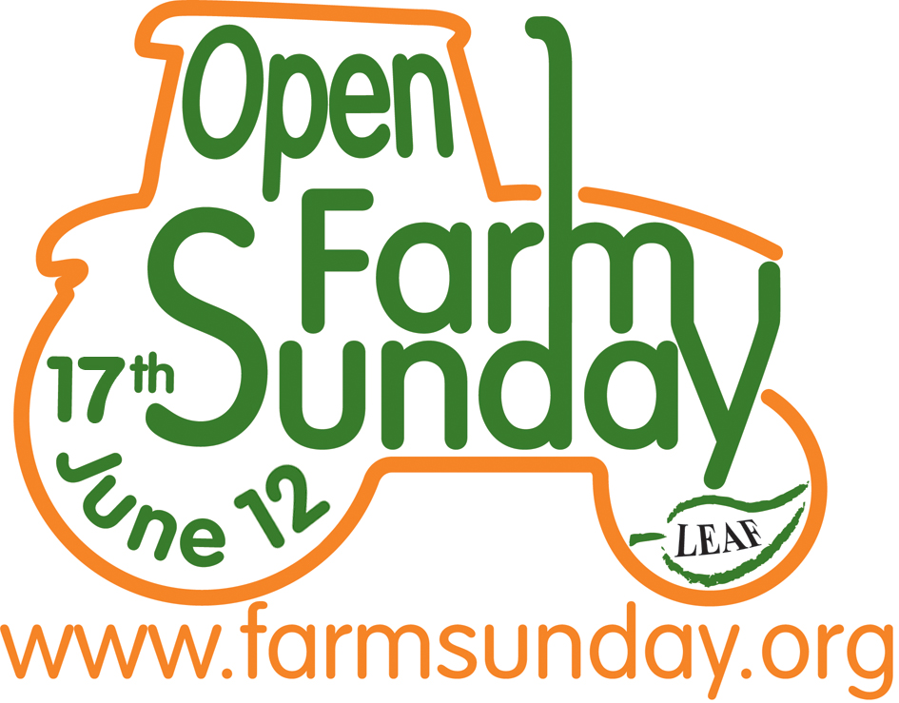
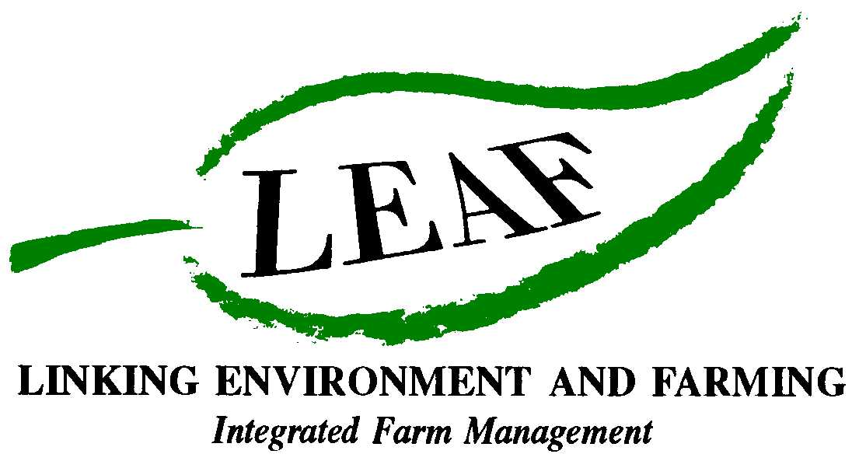

Discover Life On Our Farms!
Open Farm Sunday – 17 June 2012

Farmers across the country are inviting everyone on Open Farm Sunday (17th June) to come and discover more about food and farming. This annual event organised by LEAF (Linking Environment And Farming) is an enjoyable and informative day out for the whole family and a great way to find out how farmers produce our food and the many ways they care for the countryside too.
Hundreds of farms of all types and sizes will welcome the public on Open Farm Sunday. This is a fantastic opportunity to hear the story behind the food we all enjoy every day – from breakfast to supper. Come and discover from the farmers themselves how your morning cereals are grown, see cows being milked or cheese being made. Learn more about how your vegetables are grown and what it takes to produce all the fruit for those jars of jam we put on our toast.
Each farm visit is unique – but wherever you decide to go there is so much to see and do. Activities include guided farm walks, sheep shearing, tractor and trailer rides and nature trails. The day is also a great opportunity to discover at first hand the work farmers do to look after the countryside and how and why this is so important to the food we eat. The majority of events take place on Sunday 17 June 2012 but this year some farms will be open on alternative dates - details of which farms are opening when will be available on www.farmsunday.org
New for 2012:
- Pollinator Survey: Visitors to selected farms on Open Farm Sunday will be invited to be a scientist during the day by taking part in a new scientific survey to measure insect visitors within different habitats.
‘Pollinators’ such as bees, beetles, butterflies and hoverflies are really important to farmers, as crops pollinated by these insects help to feed billions of people every day. This is the first time there has been a national survey to monitor these important insects on farms and it’s a great way for people of all ages to have fun finding out more about these vital insects and how they help farmers produce our food. The survey is being run by LEAF with Syngenta, researchers from the Centre for Ecology and Hydrology and other scientific experts. So come and join in, and find out more about pollinators! For more information please visit www.farmsunday.org.
- www.farmsunday.org: A new look Open Farm Sunday website is being launched in 2012 which will include: regular blogs from farmers as they prepare for Open Farm Sunday; a comprehensive search facility to help visitors discover the farms that interest them the most, as well as all the latest news from the Open Farm Sunday team.
- Meet the farmer: Discover more about the farmers that run some of the many farms that open their gates on Open Farm Sunday – and their individual stories. These case studies offer a snap shot of the work they do everyday so that we all have food to eat and countryside to enjoy.

To find out which farms in your area are taking part visit www.farmsunday.org. For up-to-date campaign information and to let us know about your time on the farm, follow us on Twitter - twitter.com/openfarmsunday.
- Ends -
For further information and images, or to arrange an interview with a local farmer or preview visit to a participating LEAF farm, contact:

David Gough
Open Farm Sunday Press Office
T: 01189 475956
E: david.gough@ceres-pr.co.uk

Editor’s note:
- LEAF (Linking Environment And Farming) www.leafuk.org is a national charity (Registered no: 1045781) that helps farmers produce food with care for the environment, while working with their local community
- The seventh annual Open Farm Sunday on 17 June 2012 provides a great opportunity for the public to truly get to know how their food is produced and how the countryside around them is cared for
- Visitors will be able to learn from farmers themselves how natural plant and insect species are encouraged to thrive alongside crops, they will get a close-up look at farm animals and see how the needs of wildlife are balanced with modern food production
- LEAF organises Open Farm Sunday and supports farmers with putting on an event that is not only enjoyable, but gives visitors a really fascinating insight into aspects of the countryside that they would not usually see or experience on an average day out
- LEAF supports both LEAF and non-LEAF member farmers by hosting a number of workshops across the country with practical advice and tips for organising successful events. LEAF also provides free promotional support materials and an interactive online event database to register details of farmer events
- An increasing number of farmers are signing up to support LEAF, to demonstrate how they are integrating modern farming with environmental conservation
- Food carrying the LEAF Marque logo shows that it has been grown by farmers who are committed to looking after the countryside and the environment. LEAF farmers are subject to an independent LEAF Audit, designed to help them meet the change in demands placed on operations by legislation, the marketplace, community and the industry
- Sponsors for Open Farm Sunday 2012 include Asda, Country Life butter, Farmers Weekly, Frontier Agriculture, John Deere, LEAF Marque, Marks and Spencer, National Farmers Union, National Grid and Syngenta, plus BPEX, Dairy Co, EBLEX, HGCA, Red Tractor and FarmStay UK
- Pollinator Survey: This is being supported by Syngenta in conjunction with CEH
- The Centre for Ecology and Hydrology (CEH) is the UK's Centre of Excellence for integrated research in the land and freshwater ecosystems and their interaction with the atmosphere. CEH is part of the Natural Environment Research Council, employs more than 450 people at four major sites in England, Scotland and Wales, hosts over 150 PhD students, and has an overall budget of about £35m. CEH tackles complex environmental challenges to deliver practicable solutions so that future generations can benefit from a rich and healthy environment. www.ceh.ac.uk You can follow the latest developments in CEH research via twitter www.twitter.com/CEHScienceNews and our rss news feed http://www.ceh.ac.uk/rss/rss.xml
- Keep up to date with LEAF’s activities via twitter www.twitter.com/LEAF_Farming and our regular blogs at leafmarque.wordpress.com.

Diary Note Consumer – Open Farm Sunday 2012.doc

