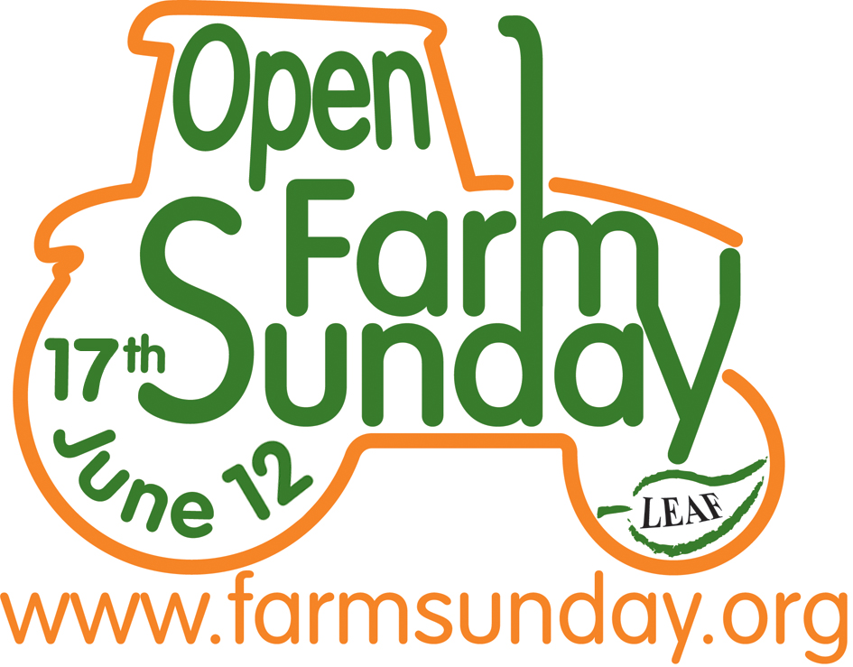
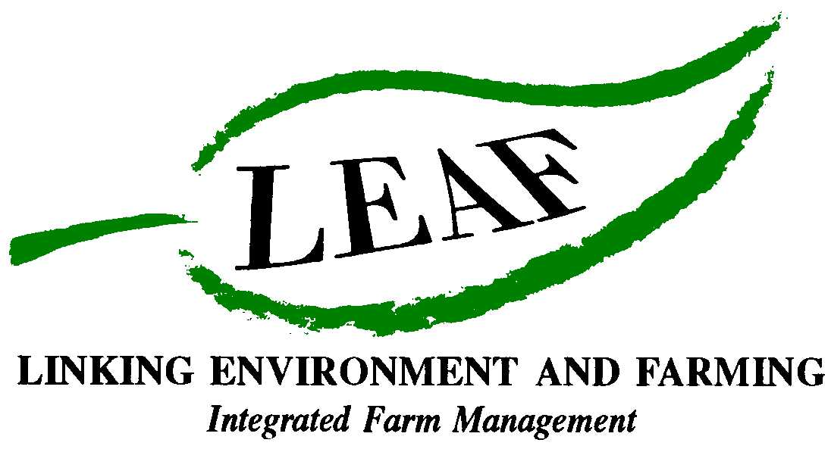

Open Farm Sunday: A breath of fresh air

Spending a day in the open air on Open Farm Sunday (17th June) is a great idea, in more ways than you might realise. Taking a stroll around your local farm is a great way to take exercise, find out more about the food you eat and could even improve your stress levels! Here are a few reasons why:

- As little as two hours spent on a farm can benefit a person’s wellbeing and help them connect with nature¹

- A closer connection with nature can improve both mental and physical health²³⁴

- 13.5 million working days are lost because of stress every year⁵

- A gentle one hour stroll along a farm trail will use 340 kcals and a more energetic two hour cross country hike around the farm will use 808 kcals6

- Research conducted for LEAF (Linking Environment And Farming) by the University of Essex on visitors to a farm showed that:
  - anger and hostility levels decreased for 70% of the visitors
  - feelings of confusion and depression decreased for 80% of visitors
  - 97% of visitors saw a reduction in their level of fatigue¹

- Connecting with nature can help boost self esteem⁷

- People who report high contact with nature are more likely to report feeling positive and on top of the world⁸

- Contact with nature can help improve your ability to concentrate⁹

- Contact with animals, plants, landscapes and wildness can improve well-being¹⁰

And did you know….?

- Biophilia is the word used to describe man’s love of nature

- Eighty percent of the UK population live in urban areas¹¹

- Over 40% of young adults (aged 16 – 24 years) have never visited a working farm¹²

- Farmers manage over 75% of the UK’s total land area

17 June 2012 will be the seventh Open Farm Sunday and hundreds of farms across the country are expected to open. To find out which farms in your area are taking part visit www.farmsunday.org. For up-to-date campaign information and to let us know about your time on the farm, follow us on Twitter - twitter.com/openfarmsunday.

1 Centre for Environment and Society, Department of Biological Sciences - University of Essex 2008

² Pretty J, Griffin M, Peacock J, Hine R, Sellens M and South N, A countryside for Health and Well-Being: The Physical and Mental Health Benefits of Green Exercise
Report for the CRN, February 2005

3 de Vries S, Verheij RA and Groenewegen PP. (2001) Nature and Health The Relation between health and green space in people’s living environment. Euro Leisure-congress Netherlands. (Submitted to Environment and Planning.)
4 Ulrich RS, Simons RF, Losito BD, Fiorito E, Miles MA, Zelson M.. Stress recovery during exposure to natural and urban environments. Journal of environmental psychology 1991; 11: 201-203.Casey ,B. University of Warwick’s Institute for Employment Research 2009
5 Casey ,B. University of Warwick’s Institute for Employment Research 2009
6 http://caloriecount.about.com/calories-burned-walking-a508 http://caloriecount.about.com/calories-burned-hiking-a483
7 Craig Chalquist (2009). A Look at the Ecotherapy Research Evidence, Ecopsychology http://www.liebertonline.com/doi/abs/10.1089/eco.2009.0003
8 T Herzog & S Strevey (2008). Contact with Nature, Sense of Humour and Psychological Well-being, Environment and Behaviour, November 2008 vol. 40 no.6 http://eab.sagepub.com/content/40/6/747.abstract
9 Ottosson J and Grahn P (2005). A comparison of leisure time spent in a garden with leisure time spent indoors: On measures of restoration in residents in geriatric care. Landscape Research
30 1 23-55 Jan 2005. Cited in Dr W Bird (2007) Natural Thinking: Investigating the links between the Natural Environment, Biodiversity and Mental Health, RSPB (http://puma.britdoc.org/resources/0000/0085/naturalthinking_tcm9-161856.pdf)

10 Frumkin (2001, 2002) cited in J, Pretty et al (2003) Green Exercise: Complementary Roles of Nature, Exercise and Diet in Physical and Emotional Well-being and Implications for Public Health Policy, CES Occasional Paper, University of Essex

11 National Statistics ‘Focus on people and migiration 2005 – the UK’s major urban area’ Graham Pointer
12 The research was undertaken by the Oxford Partnership as part of a TNS face to face omnibus survey which interviewed over 1,073 adults in England, Scotland and Wales during April 2007. Results are weighted in order to be nationally representative of the Great British population.
- Ends -
For further information and images, or to arrange an interview with a local farmer or preview visit to a participating LEAF farm, contact:

David Gough
Open Farm Sunday Press Office
T: 01189 475956
E: david.gough@ceres-pr.co.uk

Editor’s note:
- LEAF (Linking Environment And Farming) www.leafuk.org is a national charity (Registered no: 1045781) that helps farmers produce food with care for the environment, while working with their local community
- The seventh annual Open Farm Sunday on 17 June 2012 provides a great opportunity for the public to truly get to know how their food is produced and how the countryside around them is cared for
- Visitors will be able to learn from farmers themselves how natural plant and insect species are encouraged to thrive alongside crops, they will get a close-up look at farm animals and see how the needs of wildlife are balanced with modern food production
- LEAF organises Open Farm Sunday and supports farmers with putting on an event that is not only enjoyable, but gives visitors a really fascinating insight into aspects of the countryside that they would not usually see or experience on an average day out
- LEAF supports both LEAF and non-LEAF member farmers by hosting a number of workshops across the country with practical advice and tips for organising successful events. LEAF also provides free promotional support materials and an interactive online event database to register details of farmer events
- An increasing number of farmers are signing up to support LEAF, to demonstrate how they are integrating modern farming with environmental conservation
- Food carrying the LEAF Marque logo shows that it has been grown by farmers who are committed to looking after the countryside and the environment. LEAF farmers are subject to an independent LEAF Audit, designed to help them meet the change in demands placed on operations by legislation, the marketplace, community and the industry
- Sponsors for Open Farm Sunday 2012 include Asda, Country Life butter, Farmers Weekly, Frontier Agriculture, John Deere, LEAF Marque, Marks and Spencer, National Farmers Union, National Grid and Syngenta, plus BPEX, Dairy Co, EBLEX, HGCA, Red Tractor and Farm Stay UK.
- Pollinator Survey: This is being supported by Syngenta in conjunction with CEH
- The Centre for Ecology & Hydrology (CEH) is the UK’s Centre of Excellence for integrated research in the land and freshwater ecosystems and their interaction with the atmosphere. CEH is part of the Natural Environment Research Council, employs more than 450 people at four major sites in England, Scotland and Wales, hosts over 150 PhD students, and has an overall budget of about £35m. CEH tackles complex environmental challenges to deliver practicable solutions so that future generations can benefit from a rich and healthy environment. www.ceh.ac.uk You can follow the latest developments in CEH research via twitter www.twitter.com/CEHScienceNews and our rss news feed http://www.ceh.ac.uk/rss/rss.xml
- Keep up to date with LEAF’s activities via twitter www.twitter.com/LEAF_Farming and our regular blogs at leafmarque.wordpress.com.

Open Farm Sunday – A breath of fresh air.doc

