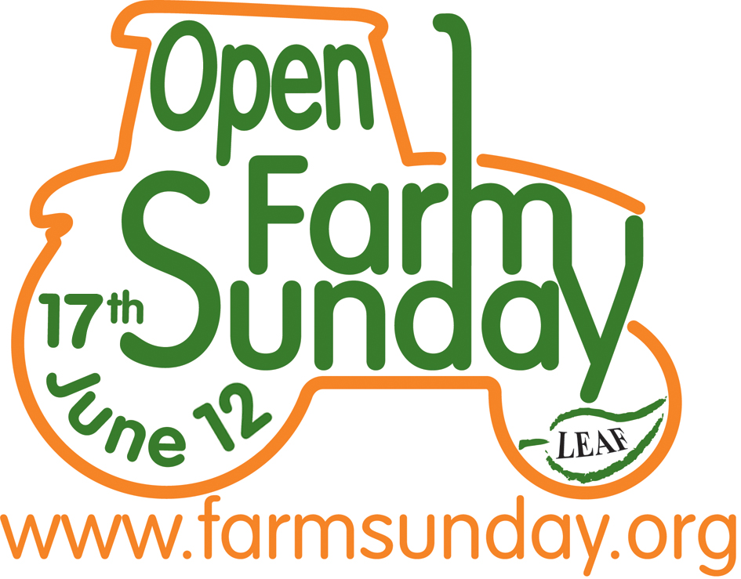
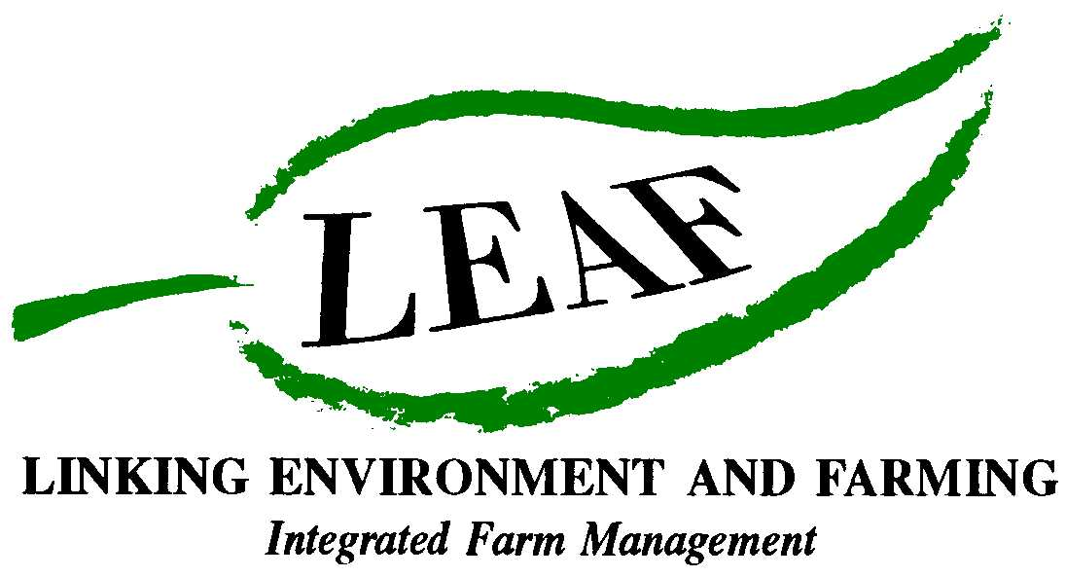

Discover the facts and figures behind food and farming
Open Farm Sunday – 17 June 2012

Why Open Farm Sunday?

- Open Farm Sunday is the only day in the year when farmers and producers across the whole of the UK unite to open their farm gates to the public. It’s organised by LEAF (Linking Environment And Farming), who established Open Farm Sunday in 2006 and have been managing it annually ever since

- Open Farm Sunday is a great way to discover more about the story behind our food – which is really important as it seems many of us don’t know much about farming and where our food comes from

Why is the British farming industry so important to everyone?

Farmers have a vital role to play in producing food for the rapidly growing population

- The agri-food sector contributed £84.6 billion to Britain’s economy and the total agri-food sector covers 14% of national employment

- There are over 195,000 farms in England, 37,000 in Wales and 51,000 in Scotlandi

What do our farmers produce?

- UK farmers produce 52% of all food consumed in the UKi

- The total area of agricultural land in the UK is 18.3million hectares on which there are:
  - 1.56 million dairy cattle
  - 4.5 million pigs
  - 1.7million beef cattle
  - 21 million sheep
  - 47 million laying hens i

- 16% (3 million hectares) of agricultural land is used to grow cereals i

- 25 million tonnes of crops, including wheat, barley, oats and sugar beet, are grown on UK farms each year. These are used in staple foods such as bread, breakfast cereals, cakes and biscuits i

- 6 million tonnes of barley, enough to make 50 billion pints of beer are grown by our farmers! i

- There are 1.56 million dairy cows in the UK – who between them produce 13 million litres of milk for dairy foods including cheese, dried milk powder, butter and yogurt

- 26% of the milk produced in the UK is used to make cheese; 253 million litres is turned into yogurt and 262 million litres of milk is used to make butterii

- UK farmers grow 60% of all the vegetables we eat - from potatoes and carrots, to peas and runner beans i

- 17,000 eggs are laid every minute on Britain’s farms

- Britain’s farmers produce 91% of the lamb and mutton, 51% of the pork products and 78% of the beef we eat

- Farms produce over 6.3 million tonnes of potatoes a year - enough to cover more than 120,000 football pitches

Who looks after the countryside and the environment?

- A 2011 survey for Open Farm Sunday revealed that 95 per cent of adults did not know that farmers manage over three quarters of the UK land mass. Less than one in four knew that farmers are responsible for looking after most of the hedgerows, walls and fences outside towns

- Farmers manage more than 85% of the countryside, which includes: looking after fences and footpaths; providing habitats for wildlife including insects, birds and animals; sowing wildflowers and planting and maintaining woodland. For example:

  - Farmers care for most of the 500,000 km of hedgerows in England and Wales – that’s enough to go 12 times round the earth (40,000km)

  - Farmers manage 323 kms of permissive footpaths

  - Farmers look after 264 kms of bridleways and cycle paths, as part of Natural England's Environmental Stewardship schemeviii

- Farming is vital in the battle against global warming. Every 100 hectares of crops soaks up between 30 and 60 tonnes of carbon a year– the same amount of carbon created by 2 UK households

- Worms are vital to the health of the soil in which farmers grow their crops. The average field on a British farm has a network of earthworm burrows about the same length as the entire UK network of major roads

How well do you know the animals and plants found on a farm?

- Sheep are not all the same! There are over 900 different sheep breeds and about 1 billion sheep in total in the world

- It’s not just people that need passports – all cattle have their own passports too, which farmers use when they move them around the country

- Pigs roll around in the mud for a very good reason! Because they don’t sweat they need to get muddy to cool off and this also helps protect them from sunburn and insect bites

- It’s the male turkeys that gobble; females make clicking and trilling noises – much more refined!

- Cows have such a good sense of smell that they can pick up smells up to 6 miles away!

- In a 2011 survey fifteen per cent of adults didn’t know that a dairy cow is female, half weren’t aware that robins live in the UK all year round and one in five didn’t know that acorns come from oak trees. vi

- Ends -
For further information and images, or to arrange an interview with a local farmer contact:

David Gough
Open Farm Sunday Press Office
T: 01189 475956
E: david.gough@ceres-pr.co.uk

- LEAF (Linking Environment And Farming) www.leafuk.org is a national charity (Registered no: 1045781) that helps farmers produce food with care for the environment, while working with their local community
- The seventh annual Open Farm Sunday on 17 June 2012 provides a great opportunity for the public to truly get to know how their food is produced and how the countryside around them is cared for
- Visitors will be able to learn from farmers themselves how natural plant and insect species are encouraged to thrive alongside crops, they will get a close-up look at farm animals and see how the needs of wildlife are balanced with modern food production
- LEAF organises Open Farm Sunday and supports farmers with putting on an event that is not only enjoyable, but gives visitors a really fascinating insight into aspects of the countryside that they would not usually see or experience on an average day out
- LEAF supports both LEAF and non-LEAF member farmers by hosting a number of workshops across the country with practical advice and tips for organising successful events. LEAF also provides free promotional support materials and an interactive online event database to register details of farmer events
- An increasing number of farmers are signing up to support LEAF, to demonstrate how they are integrating modern farming with environmental conservation
- Food carrying the LEAF Marque logo shows that it has been grown by farmers who are committed to looking after the countryside and the environment. LEAF farmers are subject to an independent LEAF Audit, designed to help them meet the change in demands placed on operations by legislation, the marketplace, community and the industry
- Sponsors for Open Farm Sunday 2012 include Asda, Country Life butter, Farmers Weekly, Frontier Agriculture, John Deere, LEAF Marque, Marks and Spencer, National Farmers Union, National Grid and Syngenta, plus BPEX, Dairy Co, EBLEX, HGCA, Red Tractor and Farm Stay UK
- Pollinator Survey: This is being supported by Syngenta in conjunction with CEH
- The Centre for Ecology and Hydrology (CEH) is the UK's Centre of Excellence for integrated research in the land and freshwater ecosystems and their interaction with the atmosphere. CEH is part of the Natural Environment Research Council, employs more than 450 people at four major sites in England, Scotland and Wales, hosts over 150 PhD students, and has an overall budget of about £35m. CEH tackles complex environmental challenges to deliver practicable solutions so that future generations can benefit from a rich and healthy environment. www.ceh.ac.uk You can follow the latest developments in CEH research via twitter www.twitter.com/CEHScienceNews and our rss news feed http://www.ceh.ac.uk/rss/rss.xml
- Keep up to date with LEAF’s activities via twitter www.twitter.com/LEAF_Farming and our regular blogs at leafmarque.wordpress.com.

Open Farm Sunday – Facts and Figures 2012.doc

Defra, 2010
Dairyco.org.uk
Egginfo,co.uk
EBLEX, BPEX: Pocketful of Meat Facts 2011
http://www.ukagriculture.com/crops/potatoes_uk.cfm
One Poll survey for LEAF, 2011
www.whyfarmingmatters.co.uk
Natural England 2007
Carbon Footprint™
Rothamsted Experimental Station
www.sheep101.com
http://www.legislation.gov.uk/uksi/1996/1686/contents/made
http://farmingfriends.com/pigs-can-suffer-sunburn-heatstroke/
http://www.fwi.co.uk/blogs/feathered-forager/2011/12/talking-turkey.html
http://www.milkcow.org/pdf_files/funfacts.pdf

