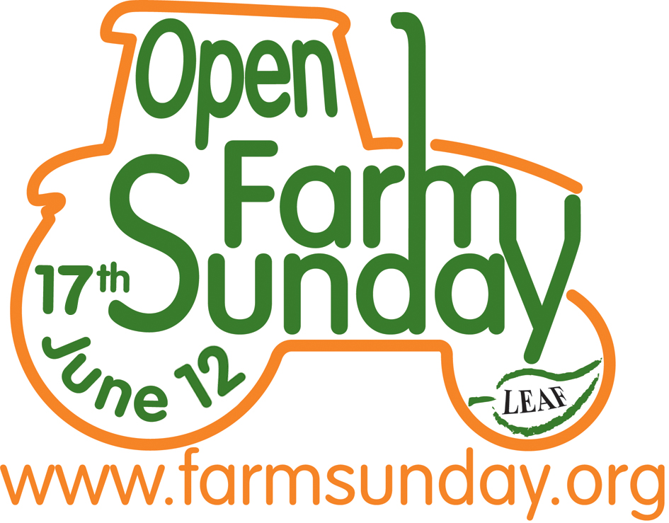
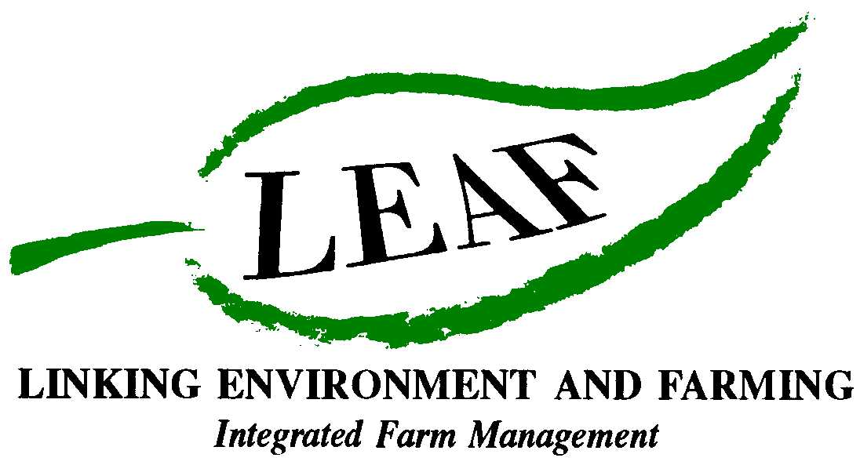

The First Ever National Farm Pollinator Survey

Taking place on Open Farm Sunday in conjunction with Syngenta and the Centre for Ecology & Hydrology

- Visitors to farms on Open Farm Sunday will be invited to help record the numbers of insects visiting plants on participating farms
- Supported by trained recorders, leaflets, posters and downloadable material
- Scientific survey with the results being made available to farmers

As farmers know, insects such as bees, ladybirds, hoverflies, butterflies and moths, are potentially essential to the production of food because they can all act as pollinators of crops. Eighty percent of plant species, including many crops, make use of insects like these, to transfer pollen between flowers to produce seeds and fruits and it is estimated that crop pollination by insects contributes about £40m to the UK economy. However, as was highlighted in a report in 2010 (ref), experts are concerned that some pollinating insects are declining.

To find out more about the activity of different insect groups and their role in providing a service on farms through pollination, on Sunday 17th June, the first ever national Farm Pollinator Survey is being held as part of LEAF’s Open Farm Sunday. The Pollinator Survey is being funded by Syngenta and supported by scientists from the Centre of Ecology & Hydrology.

Andrew Coker of Syngenta, said: “Pollinators play a vital role in agriculture, which is why we have helped create over 2,500 hectares of pollen rich strips across Europe. Now we want the public to understand that sustainable intensive agriculture is the future for both food production and preserving bio diversity and at the same time have some fun counting insects.”

Caroline Drummond, The Chief Executive from LEAF, outlines details of the Pollinator Survey. “This is both a very important scientific survey and an exciting new activity for visitors of all ages to farms on Open Farm Sunday. It also provides an ideal way for the public to see for themselves, how the work farmers do to produce our food sustainably goes hand in hand with looking after the countryside.

“Visitors to participating farms will be asked to spend a little time recording how many insects they see in two different habitats, such as a field of wheat and a margin of wildflowers. In addition the ecologists have selected five insects, including the common blue butterfly and the 14-spot ladybird, for visitors to record anywhere on the farm they visit. After Open Farm Sunday all the research will be collated and analysed by a team of scientists and the results shared with farmers to help them conserve pollinating insects on their farms.”

Dr. Helen Roy, Centre for Ecology & Hydrology says: “People across Britain have been inspirational in their enthusiasm for recording wildlife and I am sure that the Pollinator Survey will be no exception. We are looking forward to receiving the data from farms across the country.”

LEAF, Centre for Ecology & Hydrology and Syngenta are working together to provide comprehensive support materials for the Pollinator Survey, for both farmers and visitors. The survey is open to all farms to take part in and for 25 farms, at least, experts will be provided. For participating farmers, training will be provided by leading ecologist, Dr Mike Edwards and a range of online and printed materials will give instructions on how to implement the survey in a crop habitat and another habitat (such as field margin) on the farm. Visitors will receive an illustrated Pollinator guide and survey form to complete and additional information will be available at www.farmsunday.org.

In addition to the Pollinator Survey, LEAF and Syngenta have also worked with Centre for Ecology & Hydrology to develop the ‘Discover Pollinators’ activity, which will be available to all farms opening on Open Farm Sunday. Visitors will be invited to record sightings of 5 insects including the 14-spot ladybird and Common Blue Butterfly, during their farm visit – and to help them a Pollinator Guide and poster will be available. Visitors will also be encouraged to bring their cameras to the farm on Open Farm Sunday and enter their photos of insects into the photograph competition, details of which will be available at www.farmsunday.org.

Anyone wanting to get involved please call Annabel Shackleton at LEAF on 02476 413911 or visit www.farmsunday.org for more information. Visitors are also being urged to take a camera on their farm visit and enter the Open Farm Sunday photography competition.

Ends

Fascinating facts about the world of pollinators

- Honeybees are not the only pollinating insects - British bee species comprise the honeybee, about 20 bumblebee species and over 200 solitary bee species. Wild bees can be more effective on particular crops than honeybees. In apple orchards, 600 solitary bees can pollinate as well as 2 hives (30,000 honeybees). Wild bee species can be more abundant than honeybees, particularly in semi-natural ecosystems away from hives. A study in British rape fields found bumblebees were twice as abundant as honeybees

- About 80% of British plant species, including many crops, make use of insects to transfer pollen between flowers producing seeds and fruits

- The glow from a buttercup reflects UV light which it is thought attracts pollinating insects such as bees

- It is estimated that insect pollination is globally worth more than £131 billion because it is so important to farming and the production of food
- Insect pollination contributes an estimated £400m per year to the UK economy and is essential for maintaining biodiversity

- Requirement for pollinators may increase in the future because the demand for insect-pollinated crops is increasing; the area cultivated has risen by 38% since 1989 in the UK.

For further information on pollinators visit: http://www.parliament.uk/documents/post/postpn348.pdf

For further information about Open Farm Sunday and images, or to arrange an interview with a local farmer contact:
David Gough
Open Farm Sunday Press Office
T: 01189 475956
E : david.gough@ceres-pr.co.uk

- LEAF (Linking Environment And Farming) www.leafuk.org is a national charity (Registered no: 1045781) that helps farmers produce food with care for the environment, while working with their local community
- The seventh annual Open Farm Sunday on 17 June 2012 provides a great opportunity for the public to truly get to know how their food is produced and how the countryside around them is cared for
- Visitors will be able to learn from farmers themselves how natural plant and insect species are encouraged to thrive alongside crops, they will get a close-up look at farm animals and see how the needs of wildlife are balanced with modern food production
- LEAF organises Open Farm Sunday and supports farmers with putting on an event that is not only enjoyable, but gives visitors a really fascinating insight into aspects of the countryside that they would not usually see or experience on an average day out
- LEAF supports both LEAF and non-LEAF member farmers by hosting a number of workshops across the country with practical advice and tips for organising successful events. LEAF also provides free promotional support materials and an interactive online event database to register details of farmer events
- An increasing number of farmers are signing up to support LEAF, to demonstrate how they are integrating modern farming with environmental conservation
- Food carrying the LEAF Marque logo shows that it has been grown by farmers who are committed to looking after the countryside and the environment. LEAF farmers are subject to an independent LEAF Audit, designed to help them meet the change in demands placed on operations by legislation, the marketplace, community and the industry
- Sponsors for Open Farm Sunday 2012 include Asda, Country Life butter, Farmers Weekly, Frontier Agriculture, John Deere, LEAF Marque, Marks and Spencer, National Farmers Union, National Grid and Syngenta, plus BPEX, Dairy Co, EBLEX, HGCA, Red Tractor and FarmStay UK
- Pollinator Survey: This is being supported by Syngenta in conjunction with CEH
- Syngenta is one of the world's leading companies with more than 26,000 employees in over 90 countries dedicated to our purpose: Bringing plant potential to life. Through world-class science, global reach and commitment to our customers we help to increase crop productivity, protect the environment and improve health and quality of life. For more information about Syngenta please go to www.syngenta.com.
- The Centre for Ecology & Hydrology (CEH) is the UK's Centre of Excellence for integrated research in the land and freshwater ecosystems and their interaction with the atmosphere. CEH is part of the Natural Environment Research Council, employs more than 450 people at four major sites in England, Scotland and Wales, hosts over 150 PhD students, and has an overall budget of about £35m. CEH tackles complex environmental challenges to deliver practicable solutions so that future generations can benefit from a rich and healthy environment. www.ceh.ac.uk You can follow the latest developments in CEH research via twitter www.twitter.com/CEHScienceNews and our rss news feed http://www.ceh.ac.uk/rss/rss.xml
- Keep up to date with LEAF’s activities via twitter www.twitter.com/LEAF_Farming and our regular blogs at leafmarque.wordpress.com.

