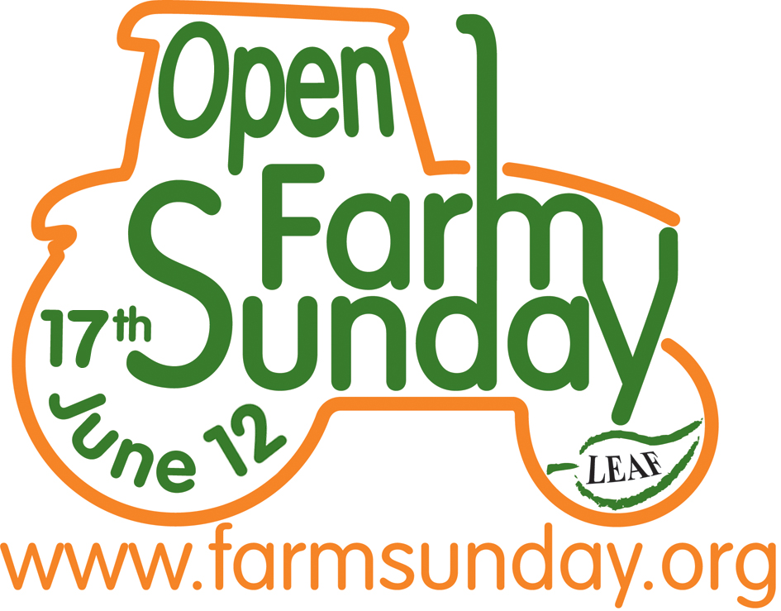
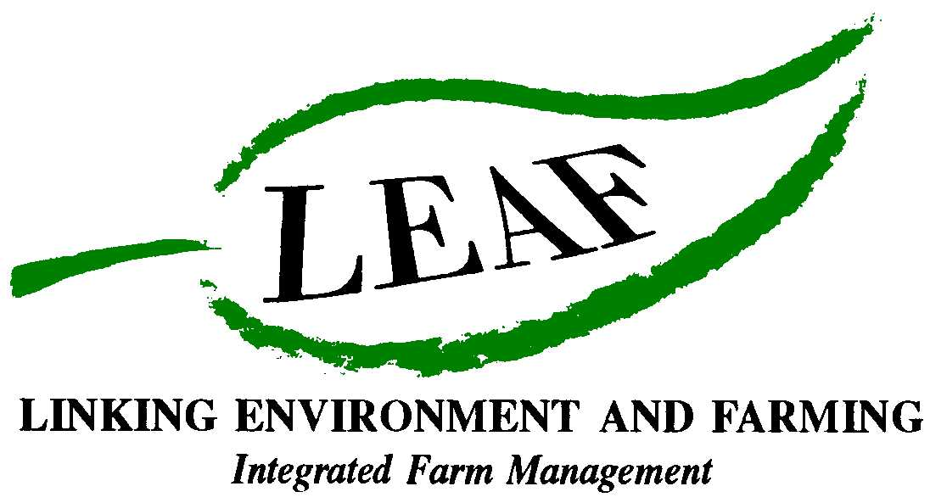

Join in the first ever national farm Pollinator Survey

And …discover what pollinators are and how they help farmers produce our food

- ‘Pollinators’ are really important to farmers, as crops pollinated by these insects help to feed billions of people every day
- There are thousands of insect species in the UK which are likely to contribute to pollination, including bees, beetles, hoverflies, butterflies and moths
- We need your help to record the numbers of insects visiting plants on our farms on Open Farm Sunday

Bees, ladybirds, butterflies and many other insects are an iconic part of the British countryside but they are also all potentially vital to farmers. This is because they can all act as pollinators of crops and so are essential for the production of our food. Eighty percent of plant species, including many crops, make use of insects like these, to transfer pollen between flowers, to produce seeds and fruits.

Because pollinators are so important, on Sunday 17th June, the first ever national farm Pollinator Survey is being held as part of Open Farm Sunday – and you can join in! Visitors to selected farms across the country are being invited to help with the scientific recording of ‘pollinators’ such as bees, beetles, hoverflies, butterflies and moths which play an important role in the production of our food.

Crops pollinated by insects help to feed billions of people at home and abroad every day because they play a critical part in the production of so many foods - from the cereal on our breakfast table, to the bread in our sandwiches as well as fruit and vegetables . Although it is estimated that crop pollination by insects contributes about £400m per year to the UK economy, scientists and farmers need to know much more about the activity of different insect groups and their role in providing a service on farms through pollination.

Caroline Drummond, The Chief Executive from LEAF, the organisers of Open Farm Sunday explains why the Pollinator Survey is happening: “LEAF (Linking Environment And Farming), has teamed up with Syngenta and the Centre for Hydrology and Ecology, to conduct a scientific survey which we hope will tell us more about these essential insects – and will also be great fun for visitors of all ages on Open Farm Sunday to be part of!”

As there are thousands of insect species in the UK alone, the scientists leading the survey are asking the public for help. Dr Helen Roy from the Centre for Ecology and Hydrology says: “We are extremely concerned that long-term (ref) surveys are highlighting declines in pollinating insects. People across the country can play a valuable part in recording pollinators on farms and help us to discover more about these important insects. We want visitors on participating farms to spend a little time recording how many insects they see in two different habitats, such as a field of wheat and a margin of wildflowers. In addition we have selected five insects, including the common blue butterfly and the 14-spot ladybird, for visitors to record anywhere on the farm they visit. After Open Farm Sunday all the research will be collated and analysed by a team of scientists and the results shared with farmers to help them conserve pollinating insects on their farms”

Visitors needn’t worry if they don’t know the bumblebee from the honey bee or a stag from a soldier beetle as there will be trained recorders on hand to help on many farms, as well as leaflets, posters and website downloads to help with the identification of the insects. More information as well as details of an exciting opportunity to take part in a photograph competition will also be available at www.farmsunday.org.

Farmers spend many hours each week caring for the environment – which includes creating and maintaining habitats for all the wildlife that live on the farm. It’s a crucial part of a farmer’s role and one they take very seriously, as this is essential to the sustainable production of the food we eat. Farmers plant hedgerows and woodland, maintain pond and footpaths and install bird and bat boxes on their farms - and many other things besides, which can all help with the effective pollination of crops.

Anyone wanting to get involved and to find a farm to visit needs to go to www.farmsunday .org for more information. Visitors are also being urged to take a camera on their farm visit and enter the Open Farm Sunday photography competition.

Ends

Fascinating facts about the world of pollinators

- Honeybees are not the only pollinating insects - British bee species comprise the honeybee, about 20 bumblebee species and over 200 solitary bee species. Wild bees can be more effective on particular crops than honeybees. In apple orchards, 600 solitary bees can pollinate as well as 2 hives (30,000 honeybees). Wild bee species can be more abundant than honeybees, particularly in semi-natural ecosystems away from hives. A study in British rape fields found bumblebees were twice as abundant as honeybees

- About 80% of British plant species, including many crops, make use of insects to transfer pollen between flowers producing seeds and fruits

- The glow from a buttercup reflects UV light which it is thought attracts pollinating insects such as bees

- It is estimated that insect pollination is globally worth more than £131 billion because it is so important to farming and the production of food
- Insect pollination contributes an estimated £400m per year to the UK economy and is essential for maintaining biodiversity

- Requirement for pollinators may increase in the future because the demand for insect-pollinated crops is increasing; the area cultivated has risen by 38% since 1989 in the UK.

For further information on pollinators visit: http://www.parliament.uk/documents/post/postpn348.pdf

For further information about Open Farm Sunday and images, or to arrange an interview with a local farmer contact:

David Gough
Open Farm Sunday Press Office
T: 01189 475956
E : david.gough@ceres-pr.co.uk

- LEAF (Linking Environment And Farming) www.leafuk.org is a national charity (Registered no: 1045781) that helps farmers produce food with care for the environment, while working with their local community
- The seventh annual Open Farm Sunday on 17 June 2012 provides a great opportunity for the public to truly get to know how their food is produced and how the countryside around them is cared for
- Visitors will be able to learn from farmers themselves how natural plant and insect species are encouraged to thrive alongside crops, they will get a close-up look at farm animals and see how the needs of wildlife are balanced with modern food production
- LEAF organises Open Farm Sunday and supports farmers with putting on an event that is not only enjoyable, but gives visitors a really fascinating insight into aspects of the countryside that they would not usually see or experience on an average day out
- LEAF supports both LEAF and non-LEAF member farmers by hosting a number of workshops across the country with practical advice and tips for organising successful events. LEAF also provides free promotional support materials and an interactive online event database to register details of farmer events
- An increasing number of farmers are signing up to support LEAF, to demonstrate how they are integrating modern farming with environmental conservation
- Food carrying the LEAF Marque logo shows that it has been grown by farmers who are committed to looking after the countryside and the environment. LEAF farmers are subject to an independent LEAF Audit, designed to help them meet the change in demands placed on operations by legislation, the marketplace, community and the industry
- Sponsors for Open Farm Sunday 2012 include Asda, Country Life butter, Farmers Weekly, Frontier Agriculture, John Deere, LEAF Marque, Marks and Spencer, National Farmers Union, National Grid and Syngenta, plus BPEX, Dairy Co, EBLEX, HGCA, Red Tractor and FarmStay UK
- Pollinator Survey: This is being supported by Syngenta in conjunction with CEH
- Syngenta is one of the world's leading companies with more than 26,000 employees in over 90 countries dedicated to our purpose: Bringing plant potential to life. Through world-class science, global reach and commitment to our customers we help to increase crop productivity, protect the environment and improve health and quality of life. For more information about Syngenta please go to www.syngenta.com.
- The Centre for Ecology and Hydrology (CEH) is the UK's Centre of Excellence for integrated research in the land and freshwater ecosystems and their interaction with the atmosphere. CEH is part of the Natural Environment Research Council, employs more than 450 people at four major sites in England, Scotland and Wales, hosts over 150 PhD students, and has an overall budget of about £35m. CEH tackles complex environmental challenges to deliver practicable solutions so that future generations can benefit from a rich and healthy environment. www.ceh.ac.uk You can follow the latest developments in CEH research via twitter www.twitter.com/CEHScienceNews and our rss news feed http://www.ceh.ac.uk/rss/rss.xml
- Keep up to date with LEAF’s activities via twitter www.twitter.com/LEAF_Farming and our regular blogs at leafmarque.wordpress.com.

Pollinator Consumer Release – Open Farm Sunday 2012.doc

